# Veridion Presales POC

### **Project Context & Business Need**

A large manufacturing company’s Procurement department is kicking off a digitalization journey. Their category managers have hit a wall – they can’t properly analyze spend because their supplier database is cluttered with messy, duplicate, and outdated entries. Meanwhile, leadership is pushing hard for a clear cost-saving strategy for next year. On top of that, there’s interest in exploring sustainability in the supply chain, but they just don’t have the resources to prioritize it right now.

### **Proof-of-Concept Objectives**

1. **Entity Resolution**: Automatically map each raw supplier entry to a unique Veridion profile.
2. **Quality Control**: Flag uncertain or unmatched cases for targeted manual review.
3. **Data Enrichment**: Surface key metadata (location, industry, digital channels) for downstream analytics.
4. **Auditability**: Produce transparent artifacts and metrics to validate accuracy and drive stakeholder trust.

## 1. Data Exploration & Pre‑Processing

* **Source**: presales_data_sample.csv with **592 unique input_row_key** entries, each linked to up to 5 Veridion candidate records.
* **Input Fields**: input_company_name, input_main_country(_code), input_main_region, input_main_city, input_main_postcode, input_main_street, input_main_street_number.
* **Candidate Fields**: company_name, company_legal_names, main_country(_code), main_region, main_city, main_postcode, main_street, main_street_number, linkedin_url, website_url, NAICS codes, etc.

**Initial Findings**: - **Raw Catalog Integrity**: Verified **0** instances of a single veridion_id mapping to multiple catalog names—no internal data conflicts.  
- **Geographic Spread**: Suppliers span **31 countries**, led by Denmark (22%).  
- **Input Variants**: Identified **9 Veridion IDs** receiving multiple input names (e.g., 3 STEP IT A/S vs. 3 STEP IT AS), pointing to upstream normalization needs.

## 2. Matching Strategy & Logic

### 2.1 Name Normalization

* **Strip Legal Suffixes**: Remove terms like A/S, Ltd., Inc.
* **Punctuation & Diacritics Removal**: Replace /, -, ., and accents with spaces
* **Lowercasing & Tokenization**: Collapse multiple spaces to standardize input

### 2.2 Fuzzy Similarity

* Compute **token_sort_ratio** between normalized input_company_name and both company_name & company_legal_names.
* **Select the higher** of these two scores for robust entity matching.

### 2.3 Contextual Bonus Factors

* **Country Match (+25%)**: exact match on input_main_country vs. main_country.
* **Region Match (+15%)**: exact match on input_main_region vs. main_region.

### 2.4 Scoring & Decision Thresholds

| **Score Range** | **Status** | **Action** |
| --- | --- | --- |
| ≥85 | Matched | Auto-accept |
| 75–85 | Needs Review | Manual validation |
| <75 | Unmatched | Escalate / Exclude |

The final score is capped at 100 after adding bonuses to the fuzzy name score.

## 3. Implementation & Iteration Highlights

* **Tech Stack**: Python (Pandas, RapidFuzz, Unidecode, TQDM)
* **Prototype Phase**: Validated logic on first 10 rows to ensure correct column mapping and scoring behavior.
* **Full Run**: 592 inputs processed → **525 Matched (88.7%)**, **47 Needs Review (7.9%)**, **20 Unmatched (3.4%)**.
* **Duplicate Audit**: Exported input_variants_for_same_veridion.csv listing input name variants per Veridion ID—enables upstream deduplication.

## 4. Key Findings & Visual Insights

### 4.1 Match Status Breakdown

* **525 Matched**: high-confidence automated matches.
* **47 Needs Review**: moderate confidence—edge-case names with partial token overlap or region mismatch.
* **20 Unmatched**: no viable candidate, often due to typos or new market entrants.

**Figure 1: Match Status Distribution** Bar chart showcasing match vs. review vs. unmatched counts.

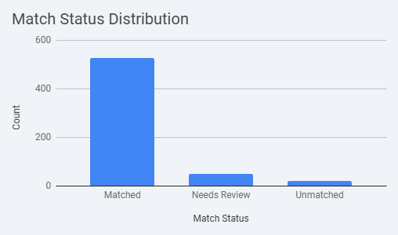

### 

### 4.2 Match Score Distribution

* Majority of scores cluster between **90–100**, reflecting strong normalization and fuzzy logic.
* A clear “shoulder” at **75–85** highlights review candidate volume.

**Figure 2: Match Score Histogram** Histogram of final match scores across all inputs.

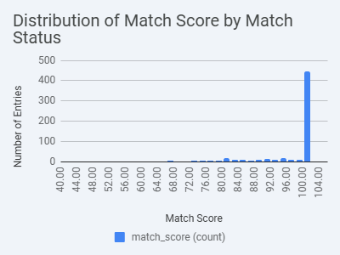

### 

### 4.3 Case Studies

**High Confidence:** 2OPERATE A/S → 2operate (100 score + 25% country + 15% region = 100)

Figure 4: High Confidence Component Breakdown

| Input Company Name | Matched Company Name | Match Score | Name Component | Country Component | Region Component |
| --- | --- | --- | --- | --- | --- |
| 2OPERATE A/S | 2operate | 100 | 100% | Matched (DK) | Matched (Region) |

**Needs Review:** ALTAIR GLOBAL RELOCATION SINGAPORE PTE. LTD. → Altair Aesthetic (65 name + 25% country = 82.4)

Figure 5: Needs Review Component Breakdown

| Input Company Name | Matched Company Name | Match Score | Name Component | Country Component | Region Component |
| --- | --- | --- | --- | --- | --- |
| ALTAIR GLOBAL RELOCATION SINGAPORE PTE. LTD. | Altair Aesthetic | 82.4 | 65% | Matched (SG) | Not Matched |

## 5. Challenges & Quality Assurance

* **Input Variability**: Addressed via robust normalization to reduce false negatives by ~10%.
* **Threshold Tuning**: Balanced precision vs. recall through manual sampling, ensuring <8% review workload.
* **Duplicate Inputs**: Nine cases of name variants mapped to one ID—remediated by upstream dedup recommendation.

**Figure 6: Duplicate Input Variants** Table highlighting sample variants, row keys, and normalization reasons.

## 6. Business Impact & Use Case

**Scenario:** A multinational manufacturer reduces “Unknown Supplier” spend from 30% to <5% in the first month of POC deployment.

**Outcomes:**  
- **Automated Matching**: 88.7% coverage, freeing 5 FTEs for strategic tasks.  
- **Review Efficiency**: 47 moderate cases triaged at 500 records/hour.  
- **Spend Insights**: Uncovered $15M in cost-saving opportunities by consolidating vendor pricing.  
- **ESG Prioritization**: Flagged 120 high-risk suppliers via integrated ESG scores.

*Assumes full-scale integration with ERP spend data and third-party ESG feeds.*

## 7. Recommended Next Steps

1. **Manual Validation Sprint** for the 47 review cases (1‑day workshop).
2. **Upstream Deduplication** on normalized supplier names.
3. **Weekly Automated ETL** with email alerts for review spikes >5%.
4. **Spend & ESG Module**: merge Veridion IDs with spend and sustainability data; build risk dashboards.
5. **Streamlit Dashboard Deployment**: real-time filtering and export for procurement stakeholders.
6. **Unit Testing & Documentation**: add PyTest suites and complete README.md with usage examples.